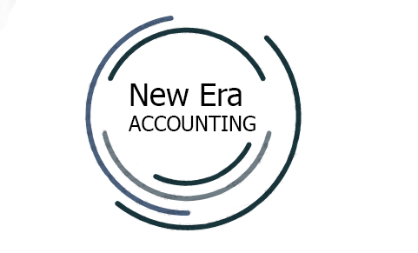
WORKED EXAMPLE OF A
YEAR-END GRADE 12 ACCOUNTING EXAMINATION
PREPARED BY NEW ERA ACCOUNTING

ANSWER BOOK
PAPER 1

Question | Maximum Marks | Achieved
1 | 60
2 | 40
3 | 50
TOTAL: | 150

This answer book consists of 7 pages.

QUESTION 1
1.1 | XOLA Ltd  STATEMENT OF COMPREHENSIVE INCOME  FOR THE YEAR ENDED 29 FEBRUARY 2020
 | Sales |  | 9 180 000
 | Cost of sales
 | ?
 | Other operating income
 | Rent income
 | ?
 | Operating expenses
 | Directors’ fees |  | 1 400 000
 | Audit fees |  | 250 000
 | Sundry expenses
 | ?
 | ?
 | Profit before interest expense
 | Interest expense |  |  |  | 26
 | Net profit before tax
 | Income tax
 | Net profit after tax |  | 861 700
1.2 | ORDINARY SHARE CAPITAL
 |  | Shares on 1 March 2019 | 8 550 000
 |  |  |  |  | 7
 |  | Shares on 29 February 2020

1.2 | RETAINED INCOME
 | Balance on 1 March 2019 | 99 300
 |  |  |  |  | 8
 | Balance on 29 February 2020
1.3 | XOLA Ltd  BALANCE SHEET (STATEMENT OF FINANCIAL POSITION)  EQUITIES AND LIABILITIES
 | Shareholders’ equity
 | Non-current liabilities
 | Current liabilities
 | Trade and other payables
 | Bank overdraft |  |  |  |  | 19
 | TOTAL EQUITY AND LIABILITIES
TOTAL
60

QUESTION 2
2.1 | 2.1.1  2.1.2  2.1.3 |  |  | 3
2.2.1 |  | Calculate the change in investments. |  | 3
 |  | Workings | Answer
 |  |  | Indicate inflow or outflow
 |  | Calculate the income tax paid. |  | 4
 |  | Workings | Answer
 |  | Calculate the proceeds from the sale of fixed assets. |  | 4
 |  | Workings | Answer
2.2.2 |  | Calculate total dividends for the 2020 financial year. |  | 4
 |  | Workings | Answer
 |  | Calculate the bank overdraft on 29 February 2020. |  | 4
 |  | Workings | Answer
2.2.3 |  | Calculate the % operating expenses for the 2020 financial year. |  | 3
 |  | Workings | Answer
 |  | Calculate the debt/equity ratio on 29 February 2020. |  | 3
 |  | Workings | Answer
 |  | Calculate the % return on average capital employed (ROCE) for the 2020 financial year. |  | 6
 |  | Workings | Answer
 |  | Interim, final & total dividends per share (see information B & D) for the 2020 financial year. |  | 5
 |  | Workings | Answer
 |  | Interim dividends per share:
 |  | Final dividends per share:
 |  | Total dividends per share:

TOTAL
40

QUESTION 3
3.1 | Explain two ways in which you would assess the solvency of any company. | 2
 | Compare the current and acid-test ratios of the two companies and explain which company has the more preferable ratios. Quote figures. | 6
 | Explain one possible problem for each company with regard to their control of the working capital items. Quote figures. | 4
3.2 | Comment on the value of the shares of the two companies on the Johannesburg Securities Exchange (JSE) for 2020. Quote figures. | 5
 | You are concerned about the price at which the new shares were issued by Rock Ltd. Explain why you would be concerned and provide evidence. | 6
 | Explain what action the directors should take.

3.3 | Comment on the degree of risk and gearing in each company. Quote two financial indicators. | 8
3.4 | Explain whether or not Mabel should be satisfied with the trend in the % return on equity (ROSHE) for each company. | 4
 | Compare the earnings per share (EPS) of each company and provide evidence to Mabel on which company has the better EPS. | 7
3.5 | Comment on the dividend pay-out policies of the two companies for 2020 and explain which company has the better policy and why that company adopted that policy. | 4
3.6 | Calculate the amount that Mabel will have to spend on buying shares on the JSE to become the majority shareholder. | 4
TOTAL
50

